Business Plan Overview
Green Impact is a Net Zero company committed to environmental responsibility and long-term success. Green Impact operates with a core belief: environmental responsibility and business success are not mutually exclusive. Our business plan outlines our strategic goals and how they are fundamentally intertwined with achieving sustainability. We aim to be a market leader in both profitability and environmental stewardship.
Our business goals, like expanding into new markets or developing innovative sustainable products, directly connect with our sustainability goals. By offering eco-friendly solutions, we attract environmentally conscious customers, driving growth. Sustainable practices throughout our operations not only reduce our environmental impact but also enhance our bottom line through reduced waste and energy consumption. This focus on both financial success and environmental responsibility allows us to be a leader in the sustainable business movement.
To solidify Green Impact’s commitment to reducing its environmental footprint, we’ve established a set of sustainability values.
Systems Thinking – Everything is connected to everything else. We make decisions based on a deep understanding of short-term and long-term impacts. ​
Perspective – Everything counts but not all things count equally. We make decisions with an understanding of the scale of impact. ​
Evolution – Everything is always changing. We keep up with trends in business, the economy, and the environment and make decisions accordingly. ​
Collective Benefit – We make decisions with the goal of helping business measurably improve the world.

How Our Business Plan Connects to Sustainability
Our business connects to sustainability through other companies.
At Green Impact, we offer GHG accounting services through the Net Zero Cloud Salesforce platform, which allows companies to begin their sustainable journey by tracking their greenhouse gas emissions. We use Salesforce internally, which is a Net Zero company itself. This helps us reduce our Scope 3 Category 2 emissions through the purchase of sustainable software. Green Impact is a remote-first company, so we have low Scope 1 and 2 emissions and reduced Scope 3 Category 7 employee commute emissions. We go to the office one day a week to reduce the amount employees must travel while still gaining the social impact of working in the office. We also prioritize virtual meetings with clients to lower Scope 3 Category 6 business travel by getting work done efficiently online as often as possible.

Energy Commitment/Plan
Green Impact is a remote-first company that produces low Scope 1 and 2 emissions. We work once per week out of a shared office space, with plans to transition to a fully remote work environment by June 2024. Our energy goals include minimizing energy usage on office days and offsetting our energy footprint through carbon offsets. After calculating Scopes 1, 2, and 3, we purchase carbon offsets annually to ensure we achieve our goal of being Net Zero.

Materiality Assessment
This assessment identifies key greenhouse gas emissions sources for Green Impact in accordance with the Greenhouse Gas (GHG) Protocol (Exhibit 1). It extends beyond direct operations (Scope 1 and 2) and provides a comprehensive view of Green Impact’s environmental footprint through its value chain. Scope 3 emissions encompasses all indirect emissions from a company’s activities, categorized as upstream (associated with the production of goods and services) and downstream (related to the use and disposal of those goods and services). The assessment has identified Scope 3 categories 2,6,7, and 15 as material to Green Impacts operations.
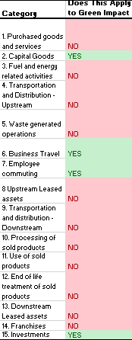

Apendix

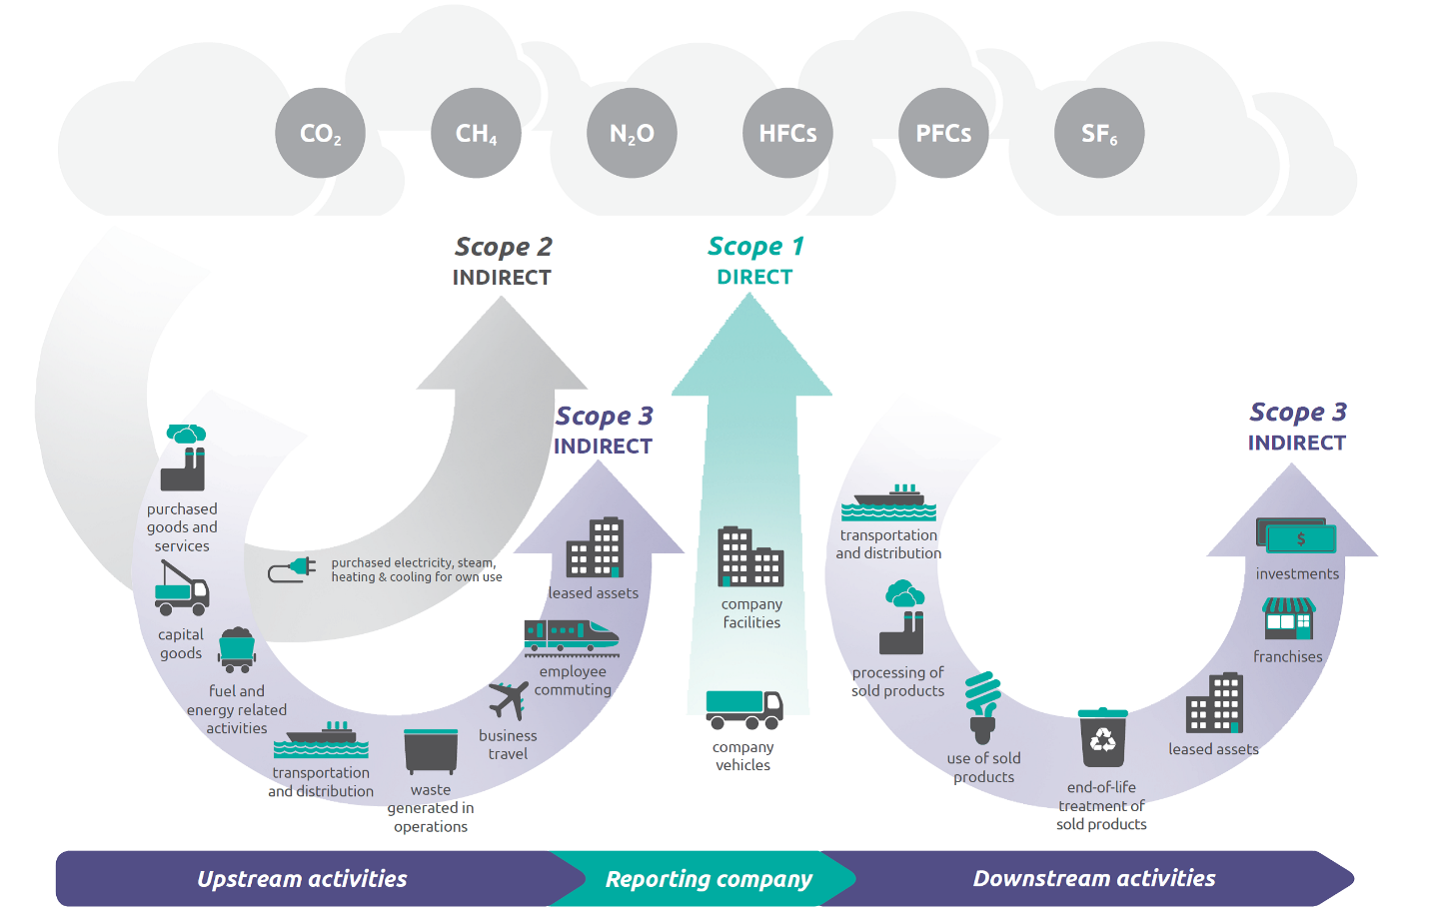
Exhibit 1: GHG Protocols

